Ideation Phase
Define the Problem Statements

Date | 31 January 2025
Team ID | LTVIP2025TMID38720
Project Name | TrafficTelligence: Advanced Traffic Volume Estimation with Machine Learning
Maximum Marks | 2 Marks

Customer Problem Statement Template:
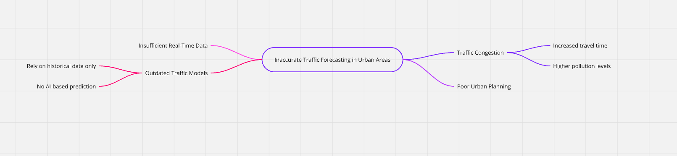
Reference: https://miro.com/templates/customer-problem-statement/
Example:
Problem Statement (PS) | I am (Customer) | I’m trying to | But | Because | Which makes me feel
PS-1 | a daily commuter in a busy city | reach my workplace on time | traffic conditions change suddenly without accurate info | I don't have access to reliable and predictive traffic updates | frustrated, anxious, and often late
PS-2 | a city traffic control authority | manage traffic efficiently during peak hours and rains | I don’t have real-time predictive data to act proactively | current tools only give live status, not future estimates | helpless, reactive instead of proactive

